DRAFT REPORT: ARE EXPANDING PINK SALMON POPULATIONS IN THE ARCTIC PRODUCED FROM REGIONAL WATERSHEDS?
PNNL Contributors: Tim Linley, Jill Janak, Steve Shen, Lisa Kant

Abstract
The Arctic is experiencing drastic environmental changes, including increasing freshwater and marine temperatures and reductions in sea ice and regional snowpack. These changes appear to be associated with the poleward expansion of sub-Arctic fish populations into the region. Pink salmon (Oncorhynchus gorbuscha), for example, are keystone species in many coastal marine ecosystems of Alaska because of their abundance, influence on nutrient flux and food web dynamics, as well as their importance as a commercial and subsistence resource. The species has been increasingly observed in Arctic Alaskan watersheds since the late 1800’s, but whether they are produced locally or originate from outside the region remains an important, yet unresolved topic of debate. The objective of this project was to use otolith geochemistry to determine if adult pink salmon captured in the Arctic originate from local waters. Water and otolith samples collected in Northwest Alaska, the Alaskan Arctic, and Prince William Sound in 2020 and 2021 were analyzed for ⁸⁷Sr/⁸⁶Sr, Sr/Ca and Ba/Ca. Based on water chemistry, ⁸⁷Sr/⁸⁶Sr was the most discriminative marker for determining the provenance of pink salmon in this study. Results indicate that the majority (65%) of adult pink salmon caught in the Alaskan Arctic do not originate from the region. Strontium isotopic ratios in the freshwater portion of the otolith are highly variable between individuals, suggesting that fish have multiple origins. However, there was a small but notable portion of fish (35%) for which Arctic origin could not be ruled out. Developing tools to better understand the use of Arctic habitat by pink salmon is critical for developing mitigation and management measures for a dynamic region.

1. Introduction
Global climate change has caused the Arctic to undergo rapid environmental changes, including increasing air and water temperatures and melting of sea ice (Huntington et al., 2020; IPCC, 2022). These physical and biogeochemical changes are resulting in drastic alterations to marine and freshwater Arctic ecosystems, which will likely increase in severity as Arctic warming trends continue (Huntington et al., 2020; Mueter et al., 2017). Although it is clear that global climate change will have profound impacts on Arctic ecosystems, understanding ecosystem dynamics in a rapidly changing and remote environment can be challenging. However, it is critical to increase our understanding of the current and future impacts of global climate change on Arctic ecosystems so that impacts can be managed and mitigated.
Physical changes in the Arctic have already had dramatic impacts on regional freshwater and marine ecosystems. These impacts have spanned the entire ecosystem, from changes in the microbiome (Hutchins et al., 2019) and primary productivity (Ardyna and Arrigo, 2020) to significant impacts on apex predators like polar bears (Wiig et al., 2008). In addition to drastic changes in the marine environment, Arctic freshwater ecosystems are projected to experience changes in primary productivity, partially driven by increasing nutrient fluxes from terrestrial input, which will have dramatic effects on the entire food web (CAFF, 2019; Wrona et al., 2016). Shifts in distribution and abundance of a variety of species, including copepods, fish, seabirds, seals, and whales have already been documented (Huntington et al., 2020). In addition to impacts on native Arctic species, physical environmental changes will allow for the range expansion of sub-Arctic species. Models predict that the Arctic will have among the highest changes in fisheries catch potential worldwide (>20%), driven by a large number of invasive species (Cheung et al., 2016).
Many native fish species are a critical resource in the Arctic due to their economic, cultural, and ecological significance. In response to increasing temperatures, non-native fish species have expanded in range and taken advantage of previously inhospitable habitats and may have significant impacts on the Arctic ecosystem. Poleward expansion in the distribution of sub-Arctic fish populations at rates that match climatic shifts in local environments have already been documented and have resulted in significant ecological impacts for native fish species, including notable changes in the location and range of Arctic fish species (Fossheim et al., 2015). Small increases (e.g., 2-3°C) in water temperature at high latitudes are predicted to result in dramatic changes in the range of sub-Arctic fish (Campana et al., 2020). Native Arctic fish species, such as Arctic cod (Boreogadus saida), are already predicted to face significant declines in range and abundance under global climate change scenarios (Dommasnes, 2010; Steiner et al., 2019). The expansion of non-native fish into the region could exacerbate predicted declines in native fish communities, therefore imparting a disproportionate and detrimental impact on Arctic indigenous communities that practice subsistence fishing. Further, interactions between native and non-native species have the potential to impact the entire Arctic ecosystem food web (Pecuchet et al., 2020). In order to develop mitigation and management strategies for subsistence fishing communities, it is critical to understand current and future habitat use patterns of sub-Arctic fish.
Pacific salmon (Oncorhynchus spp.) provide an excellent example of sub-Arctic fish likely to colonize newly available habitats in the Arctic. At lower latitudes, Pacific salmon are highly sought after in commercial and sport fisheries, as well as being an ecological keystone species. Overall, Pacific salmon face large-scale impacts from global climate change, including decreases in spawning habitat and impacts from increasing sea surface temperatures (Abdul-Aziz et al., 2011; Crozier et al., 2021). However, both plastic and evolutionary responses will help Pacific salmon to adapt to global warming trends (Crozier et al., 2011, 2008; Crozier and Hutchings, 2014; Sparks et al., 2017).
While most Pacific salmon species have high site fidelity and natal homing, pink salmon (O. gorbuscha) have demonstrated relatively high rates of straying (Quinn, 2004) – indicating their high potential to colonize newly available habitat in the Arctic. Pink salmon have historically been observed in the Arctic in relatively low abundance (on the order of single-digit fish prior to 2003) (Dunmall et al., 2013). However, more recent reporting has indicated an increase in the abundance and distribution of pink salmon in the Alaskan Arctic (Carothers et al., 2019, 2018; Dunmall et al., 2013), including spawning adults (Carothers et al., 2019). Although one juvenile chum salmon (O. keta) has been captured in the Arctic (Dunmall et al., 2022), which indicates the potential for other Pacific salmon species in the region, the production of successful offspring of pink salmon in the Alaskan Arctic has not been verified. However, it is unclear if the pink salmon observed in the Alaskan Arctic are transients or if local watersheds are producing pink salmon.
The presence of pink salmon in the Arctic presents a variety of implications. While pink salmon could present new economic and subsistence opportunities for the region, these fish will also likely impact traditional subsistence fish, such as whitefish and Arctic grayling. However, verifying the successful spawning of fish in a vast and dynamic region like the Arctic presents a difficult challenge. Traditional fish tracking methods encompass a variety of tagging methods, including radio-tagging (Jepsen et al., 1998) and acoustic telemetry (McMichael et al., 2010). Mitochondrial DNA has also been used to investigate the origin of individual fish (Bermingham et al., 1991), however; reference populations are needed for matching DNA from unknown fish. Due to the size of the region in question and difficulties with conducting research in a remote area, these traditional methods are not suitable for preliminary investigations on the origins of pink salmon in the Arctic.
Otoliths are a widely used tool in the fisheries community to determine the origins of fish (as reviewed by Reis-Santos et al., 2022; Walther, 2019). Otoliths are chemically inert structures, made up of calcium carbonate, typically in the form of aragonite. As otoliths incorporate elements from the surrounding water daily, if the geochemical signature of the water is known, they can be used to determine the origins and migration patterns of fish (Campana, 1999; Thorrold et al., 1998). A variety of geochemical markers, such as ⁸⁷Sr/⁸⁶Sr, elemental/calcium ratios (e.g., Sr/Ca, Ba/Ca), and light stable isotope ratios (e.g., δ¹⁸O, δ¹³C) have been used to determine the origins of many different fish species (Gibson-Reinemer et al., 2009; Kennedy et al., 2000; Nims and Walther, 2014; Rooker et al., 2008).
However, it is possible that the use of otoliths to establish origins of pink salmon could be complicated by their life history. While other Pacific salmon species spend extended periods rearing as juveniles in freshwater, pink salmon migrate to the ocean almost immediately after emergence from the gravel (Quinn, 2004). Previous studies have demonstrated that it takes approximately 3-4 weeks for otolith chemistry to reach equilibrium with the water (Doubleday et al., 2013), although changes in otolith chemistry can be seen in 2-3 days (Chen et al., 2015). Although there is currently no available literature on the use of otoliths to determine natal origins of pink salmon, otolith microchemistry has been used successfully to identify origins of chum salmon (Zimmerman et al., 2013). Chum, like pink salmon, also have a limited period of freshwater rearing (Quinn, 2004). The successful use of otolith microchemistry to identify origins of Chum salmon indicates that there is promise that this technique could also be applied to pink salmon in order to better understand fish origins and movement in a dynamic region.
The objectives of this project were thus to 1) determine if otolith microchemistry could be used to identify the origins of pink salmon and 2) evaluate if local Arctic watersheds in Northern Alaska support the production of pink salmon.

2. Materials and Methods

2.1 Study Area and Sample Collection
Water samples from Prince William Sound (PWS) were collected by PWS Science Center personnel in July and August 2020. Water samples from Northern Alaska (AK) locations were collected by North Slope Borough personnel in July and August 2020 and October 2021. One water sample was collected per site. Sample sites were selected to attain a broad spatial representation of water chemistry throughout Northern AK. Given that the objective of the study was focused on determining the origin of pink salmon caught in the Arctic, this study focused on capturing the geographic rather than temporal variation in tributary water chemistry in Northern AK. Although AK streams have been shown to demonstrate inter-annual variation in ⁸⁷Sr/⁸⁶Sr (Brennan et al., 2015), geochemical differences among streams are typically greater than seasonal differences (Barnett-Johnson et al., 2008; Brennan et al., 2015; Hegg et al., 2013).
Water samples were collected in acid-washed 60 mL perfluoroalkoxy alkane (PFA) bottles following the procedures described by Linley et al. (2016). After collection, water samples were refrigerated until they could be shipped to Pacific Northwest National Laboratory (PNNL). Upon arrival at PNNL, water samples were acidified to 2% with Optima-grade nitric acid (Fisher Scientific).
Adult pink salmon from PWS were collected in July and August of 2020. These salmon were from known, established populations in PWS. Fish in PWS were collected from either Hartney Bay or Jackson Creek, which are home to known, established pink salmon populations. Run size of PWS pink salmon was estimated to be between 50 – 142 million individuals between 2013 – 2015, of which an estimated 56 – 86% are of hatchery origin (Knudsen et al., 2021). In addition to spawning in freshwater, a significant number of pink salmon in PWS have been documented spawning in intertidal zones (Helle, 1970). Fish from Hartney Creek were captured using blocking seines and dipnets. At Jackson Creek, post-spawn carcasses were collected from the water or riverbank.
Adult pink salmon from Northern Alaska were caught by native fishers engaged in subsistence fishing using gill nets in July and August of 2020 and 2021. Fish were collected opportunistically in three different marine locations (Elson Lagoon, Kaktovik, Point Hope). Elson Lagoon is a bay located on the North Slope of AK, near Utqiaġvik (formerly Barrow). The Elson Lagoon watershed is made up of many small streams, draining an area of approximately 580 km² (Rawlins, 2021). The salinity of Elson Lagoon varies from 5 – 30 ppt, while water temperature ranges from -1 to 14°C (Sformo et al., 2019). These changes in temperature and salinity are driven by seasonal differences in runoff, contribution of sea ice melt, and mixing of sea water from the Beaufort and Chukchi Seas via wind-inducement movement (Sformo et al., 2019). Samples from Kaktovik were caught in a lagoon with similar conditions to Elson Lagoon. Samples from Point Hope were collected in the nearshore ocean on the southside of the city of Point Hope. Samples from Camp-99 were captured in freshwater in an unnamed tributary to the Inaru River, located 28 river miles upstream from Elson Lagoon. Otoliths were harvested from fish, rinsed, dried, and shipped to PNNL for analysis.

2.2 Water Sample Preparation and Analysis
Water samples were filtered (PFA, 1-2 µm) and heated at 80°C until completely dry. To remove organic matter, samples were treated with ultra-high purity 15M nitric acid, dried down completely, and then treated with 30% hydrogen peroxide. This procedure was carried out at least 3 times. Samples were then re-suspended in 7M nitric acid and divided into aliquots for Sr isotopic and elemental analysis.
Cation column procedures to purify the Sr aliquot for isotopic analyses were done using Eichrom Sr Spec resin, following the procedures described in Dunnigan et al. (2023). To prevent contamination, sample preparation and column chemistry procedures were performed under a class 100 laminar flow hood.
Water samples were analyzed for ⁸⁷Sr/⁸⁶Sr by multi-collector inductively coupled plasma mass spectrometry (MC-ICP-MS, NuPlasma 3, Nu Instruments). The Sr carbonate isotopic standard reference material SRM 987 (National Institute of Standards and Technology [NIST]) was analyzed prior to and throughout the analysis to assess instrument performance. Replicate analyses of SRM 987 yielded a mean value of 0.71025+0.00001 (n=8), compared to the literature reported value of ⁸⁷Sr/⁸⁶Sr = 0.71025 (GeoRem, 2022).
Water samples for elemental concentrations were diluted to appropriate concentrations for analysis using 2% nitric acid. Samples were analyzed quantitatively for ⁴³Ca, ⁸⁸Sr, and ¹³⁷Ba using a Thermo Scientific X-Series II quadrupole inductively couple plasma mass spectrometer (Q-ICP-MS). An internal standard solution of indium was added in-line to samples prior to introduction into the instrument in order to monitor instrument stability. The instrument was calibrated using an external standard calibration curve (standard concentrations ranging from 0.05 – 10 parts per billion; High-Purity Standards Corporation). A series of calibration and blank verification checks were analyzed after the initial instrument calibration and after every 10 samples. All measured calibration verifications were within +10% of their known concentrations, while all blank verifications were below calculated detection limits.

2.3 Otolith Preparation and Analysis
In preparation for laser ablation analysis, otoliths were first mounted on glass sides using thermoplastic glue (Crystalbond 509). Due to their small size, otoliths did not need to be sectioned. Otoliths were polished on both sides, in the sagittal plane, until the core was visible. Silicon carbide sanding paper of successively finer grit (400 – 1200 grit, Allied High-Tech Products) was used in the polishing process.
Otoliths were analyzed via laser ablation by using a NWR 213nm Nd:YAG laser (Electro Scientific Industries, Inc.), coupled to the ICP-MS instruments previously described above for their respective analyses. Prior to analysis, a low-powered laser pulse (5% power) was used as a cleaning pass across the otolith to remove potential surface contamination prior to analysis (Gover et al., 2014). Laser analysis transects were laid from outside the freshwater zone (early ocean) of the otolith, passing directly through the core, to outside the freshwater zone on the opposite side, perpendicular to the sulcus. Parameters for laser ablation are as follows, spot size: 40 µm, power output: 50%, scan speed: 3 µm/second, repetition rate: 5 Hz. For both isotopic and elemental analysis, the ablated material was carried from the laser to the ICP-MS using a flow of argon carrier gas at 500 mL/min. Sample washout was monitored between each otolith sample to ensure that signals had returned to background levels before proceeding with subsequent analyses.
For Sr isotopic analyses, the MC-ICP-MS was tuned using a marine coral standard to ensure that the ⁸⁷Sr/⁸⁶Sr value of modern seawater (⁸⁷Sr/⁸⁶Sr = 0.70918; Elderfield, 1986) was obtained within 2 standard errors (⁸⁷Sr/⁸⁶Sr = 0.70916 + 0.00003, n = 21). The same coral standard was analyzed after every 10-15 samples to monitor instrument drift. To correct for the isobaric interference of Krypton-84 with Sr-84, on-peak zeroes were measured and subtracted prior to each run. A Rb-86 correction was also applied to the Sr-86 signal by measuring the Rubidium-85 signal and calculating the corresponding Rb-86 value assuming natural Rb isotopic composition. To account for mass fractionation, an exponential correction factor (Equation 1; Russell et al., 1978) was obtained from the measured ⁸⁶Sr/⁸⁸Sr based on its variation from the accepted value of 0.1194. This was then applied to the ⁸⁷Sr/⁸⁶Sr ratio.
$True Ratio=Measured Ratio*{\left(\frac{Atomic Mass of X}{Atomic Mass of Y}\right)}^{Fractionation Factor}$(Eqn 1)
For elemental analysis, an external calibration curve was constructed using two silicate glass standard reference materials (SRM 612 and 610; NIST). Known values for reference materials were taken from (Pearce et al., 1997). Samples were analyzed quantitatively for ⁴³Ca, ⁸⁸Sr, and ¹³⁷Ba. All data was background subtracted by running blanks prior to analysis. The instrument was re-calibrated each time that the laser chamber was opened to change samples (~n=15). Otolith elemental concentration data was converted to element to calcium molar ratios for reporting.

2.4 Identifying the Core and Freshwater Regions in the Otolith
Otolith data was smoothed using a 7-point moving average to reduce variation in signal due to the laser ablation sampling method. Core and freshwater regions in the otolith were first identified on ⁸⁷Sr/⁸⁶Sr transects and then the corresponding portion in the Sr/Ca and Ba/Ca transect was extracted. To identify these otolith regions, ⁸⁷Sr/⁸⁶Sr transects from laser ablation analyses were first plotted in relation to distance from the core. The core region in most otoliths was easily identifiable for strontium isotopic signatures due to its proximity to the global marine ⁸⁷Sr/⁸⁶Sr value. The beginning of the freshwater transect of the otolith was identified as a significant departure (positive or negative) from the core value. The end of the freshwater transect was identified as a return to the global marine ⁸⁷Sr/⁸⁶Sr value. Once the freshwater portion of the otolith was established, the maximum or minimum freshwater ⁸⁷Sr/⁸⁶Sr value was identified and a 10-point average around this point was taken. This value was reported as the freshwater value for each individual fish.

2.5 Statistical Analyses
Statistical analysis could not be carried out on water samples due to small sample sizes. Therefore, differences in the ranges of water values were examined visually using box and whisker plots.
Prior to analysis, the otolith data were examined for normality (Shapiro-Wilk test) and equality of variances (Levene’s test). Due to the data being non-normally distributed, Kruskal-Wallis and Conover-Iman pairwise comparisons were used to tests for statistical differences between groups of fish. A Bonferroni correction was applied to the Conover-Iman pairwise comparisons to account for small sample sizes. First, differences between the two populations of fish from PWS for the otolith core and freshwater portions otolith for ⁸⁷Sr/⁸⁶Sr, Sr/Ca, and Ba/Ca were examined. As there were no significant differences between these two groups, fish from PWS were combined into one group for subsequent analyses. Fish from Northern AK locations were examined for significant differences based on their capture location (e.g., Camp-99, Elson Lagoon, Kaktovik, Point Hope). The level of significance for all tests was α < 0.05. Python was used for all statistical tests.

3. Results

3.1 Water Chemistry
Water results at each sampling location are presented in Table 5.1. Water data were averaged for the Northern Alaska (NAK) and PWS locations for comparison to otolith values (Figure 5.1). NAK water has a geochemical signature that is distinct from PWS for ⁸⁷Sr/⁸⁶Sr, while Ba/Ca and Sr/Ca have overlap between NAK and PWS locations (Figure 5.1). However, Ba/Ca of NAK water has a much broader range as compared to PWS, meaning that Ba/Ca could potentially be used to determine if pink salmon are of Northern Alaskan origin if fish have otolith Ba/Ca signatures well outside of the range of PWS water. Strontium isotopes for NAK locations range from 0.709300 (Kokolik River) to 0.714305 (Kobuk River) (Table 5.1). Water ⁸⁷Sr/⁸⁶Sr values from this study are in agreement with the regional trends in Sr isotopic composition for AK rivers presented in (Brennan et al., 2014) (Figure 5.2).

3.2 Otolith Chemistry
⁸⁷Sr/⁸⁶Sr
Otolith data is summarized in Table 5.2. There were significant differences between NAK fish based on catch location for ⁸⁷Sr/⁸⁶Sr in the freshwater and core portion of the otolith (Table 5.3).

Table 5.1. Location, ⁸⁷Sr/⁸⁶Sr, and elemental ratios (mmol/mol) for water samples collected in Northern Alaska (NAK) and Prince William Sound (PWS).
Region | Site | Site Code | Lat | Long |  | ⁸⁷Sr/⁸⁶Sr | Std Error | Sr/Ca (mmol/mol) | +1 SD | Ba/Ca (mmol/mol) | +1 SD
Northern Alaska (NAK) | Colville River | CR | 70.22165 | -150.992 |  | 0.711194 | 9.78E-06 | 1.57 | 0.026 | 1.08 | 0.038
Northern Alaska (NAK) | Meade River | MR | 70.479694 | -157.406 |  | 0.711234 | 1.09E-05 | 1.17 | 0.037 | 1.04 | 0.023
Northern Alaska (NAK) | Kobuk River | KB | 66.961158 | -160.460 |  | 0.714305 | 8.12E-06 | 2.19 | 0.032 | 0.205 | 0.013
Northern Alaska (NAK) | Kokolik River | KK | 69.74905 | -162.934 |  | 0.709300 | 8.86E-06 | 7.94 | 0.099 | 0.526 | 0.011
Northern Alaska (NAK) | Topagorok River | TG | 70.756193 | -155.929 |  | 0.710112 | 8.79E-06 | 1.61 | 0.026 | 0.935 | 0.026
Northern Alaska (NAK) | Kukpowruk River | KR | 69.615593 | -163.015 |  | 0.709932 | 8.78E-06 | 3.66 | 0.039 | 0.505 | 0.010
Northern Alaska (NAK) | Camp-99 | C99 | 70.94694 | -156.648 |  | 0.710321 | 7.86E-06 | 2.37 | 0.019 | 1.43 | 0.024
Northern Alaska (NAK) | Tusikvaak Lake | TL | 71.12550 | -156.180 |  | 0.711189 | 4.79E-05 | 2.50 | 0.007 | 1.64 | 0.013
Northern Alaska (NAK) | No Name | NN | 69.514075 | -154.779 |  | 0.712851 | 5.30E-05 | 1.62 | 0.023 | 1.32 | 0.003
Northern Alaska (NAK) | Kukpuk River | KP | 68.38426 | -166.298 |  | 0.710518 | 9.36E-06 | 3.39 | 0.056 | 0.542 | 0.013
Northern Alaska (NAK) | Noatak River | NT | 67.166018 | -162.590 |  | 0.712859 | 7.40E-06 | 1.58 | 0.0090 | 0.398 | 0.004
Northern Alaska (NAK) | Northern Alaska Mean +1SD |  |  |  |  | 0.711256 | 1.51E-03 | 2.69 | 1.91 | 0.874 | 0.470
Prince William Sound (PWS) | Jackson Creek | JC | 60.324029 | -148.279 |  | 0.707446 | 8.27E-06 | 2.47 | 0.120 | 0.340 | 0.027
Prince William Sound (PWS) | Hartney Bay | HB | 60.502129 | -145.860 |  | 0.707002 | 7.33E-06 | 6.18 | 0.242 | 0.339 | 0.002
Prince William Sound (PWS) | Prince William Mean +1SD |  |  |  |  | 0.707224 | 3.14E-04 | 4.32 | 2.62 | 0.339 | 0.001

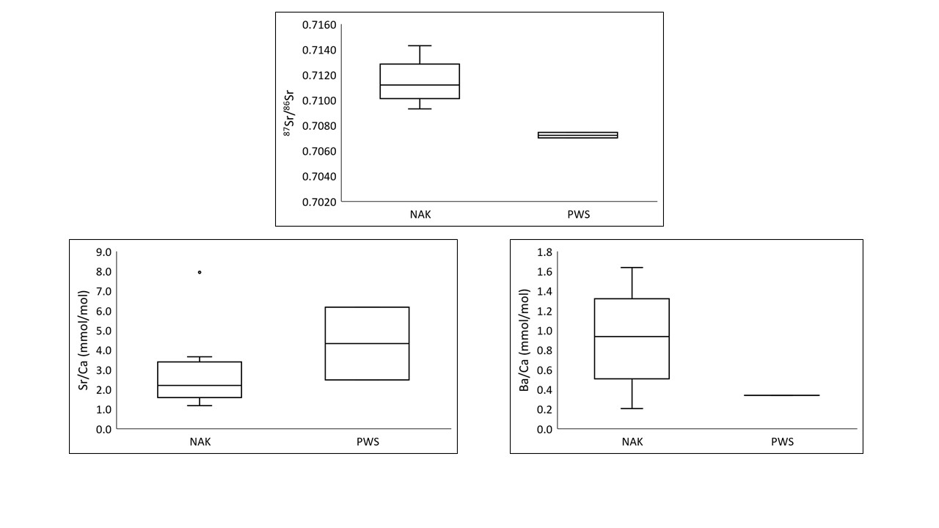
Figure 5.1. The ⁸⁷Sr/⁸⁶Sr and elemental ratios of water samples collected in Northern Alaska (NAK) and Prince William Sound (PWS). The median is represented by the horizontal line through each box, the 25th and 75th percentiles are represented by the lower and upper boundaries, respectively; the 10th and 90th percentiles are represented by the whiskers. Outliers are represented by filled circles.

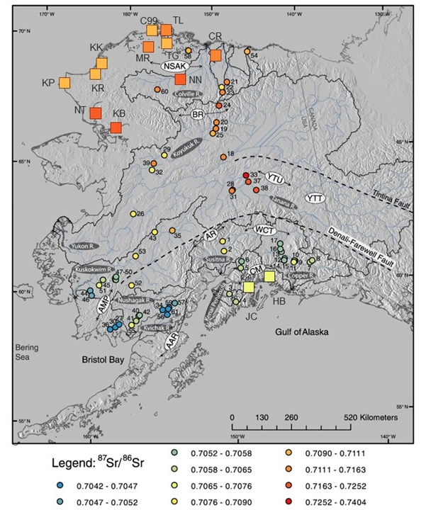
Figure 5.2. The ⁸⁷Sr/⁸⁶Sr of Alaskan Rivers as reported in Brennan et al. (2014; circles) and this study (squares). The water ⁸⁷Sr/⁸⁶Sr results from this study are in general agreement with the Sr isotopic data for AK rivers previously published and follow the general trends in Alaskan bedrock geology. Abbreviations for river names can be found in Table 5.1. River identification numbers can be found in Brennan et al., (2014). Geological features of AK are represented as follows: AR – Alaska Range, BR = Brooks Range, NSAK = North Slope of AK, YTU = Yukon Tanana Uplands, AAR = Alaskan-Aleutian Range, AMP = Ahklun Mountain Province, CM = Chugach Mountains. Figure reproduced with permission.

Table 5.2. Otolith core and freshwater (FW) values for ⁸⁷Sr/⁸⁶Sr and elemental ratios for adult pink salmon captured in Northern Alaska (NAK) and Prince William Sound (PWS).
 |  | ⁸⁷Sr/⁸⁶Sr |  |  |  |  |  | Sr/Ca (mmol/mol) |  |  |  |  | Ba/Ca (µmol/mol)
Region | Site | Core | +1 SD | FW | +1 SD | n | Core |  | +1 SD | FW | +1 SD | n | Core | +1 SD | FW | +1 SD | n
Northern AK (NAK) | Camp 99 | 0.70918 | 0.0004 | 0.70910 | 0.0008 | 14 | 1.91 |  | 0.21 | 1.59 | 0.21 | 6 | 6.98 | 2.75 | 10.1 | 4.44 | 6
Northern AK (NAK) | Elson Lagoon | 0.70894 | 0.0004 | 0.70874 | 0.0007 | 83 | 2.22 |  | 0.44 | 1.99 | 0.43 | 58 | 8.27 | 4.26 | 12.7 | 6.91 | 58
Northern AK (NAK) | Kaktovik | 0.70875 | 0.0004 | 0.70861 | 0.0004 | 5 | 2.50 |  | 0.93 | 2.35 | 0.98 | 5 | 7.88 | 1.59 | 7.51 | 4.33 | 5
Northern AK (NAK) | Point Hope | 0.70852 | 0.0003 | 0.70816 | 0.0007 | 14 | 3.97 |  | 0.84 | 3.74 | 0.95 | 14 | 22.5 | 12.11 | 16.9 | 15.4 | 14
Northern AK (NAK) | Mean +1SD | 0.70885 | 0.0003 | 0.70865 | 0.0004 | 116 | 2.65 |  | 0.91 | 2.42 | 0.94 | 83 | 11.4 | 7.41 | 11.80 | 4.03 | 83
Prince William Sound (PWS) | Hartney Bay | 0.70900 | 0.0005 | 0.70894 | 0.0008 | 18 | 2.26 |  | 0.27 | 2.32 | 0.41 | 13 | 31.9 | 18.7 | 35.0 | 20.0 | 13
Prince William Sound (PWS) | Jackson Creek | 0.70918 | 0.0006 | 0.70920 | 0.0004 | 19 | 2.44 |  | 0.41 | 2.30 | 0.24 | 14 | 2.44 | 14.0 | 29.1 | 13.4 | 14
Prince William Sound (PWS) | Mean +1SD | 0.70909 | 0.0001 | 0.70907 | 0.0002 | 37 | 2.35 |  | 0.13 | 2.31 | 0.01 | 27 | 17.2 | 20.8 | 32.1 | 4.15 | 27

Table 5.3. Results from Kruskal-Wallis analyses to determine significant differences between groups of fish captured in Northern Alaska for different analytes and otolith regions (core or freshwater).
Analyte | Otolith Region | Group | Test Statistic | p
⁸⁷Sr/⁸⁶Sr | Freshwater | C99ª | 8.20 | 0.0420
⁸⁷Sr/⁸⁶Sr | Freshwater | ELª | 8.20 | 0.0420
⁸⁷Sr/⁸⁶Sr | Freshwater | KK^{a,b} | 8.20 | 0.0420
⁸⁷Sr/⁸⁶Sr | Freshwater | PH^{b} | 8.20 | 0.0420
⁸⁷Sr/⁸⁶Sr | Core | C99ª | 21.50 | 8.29E-05
⁸⁷Sr/⁸⁶Sr | Core | EL^{b} | 21.50 | 8.29E-05
⁸⁷Sr/⁸⁶Sr | Core | KK^{b,c} | 21.50 | 8.29E-05
⁸⁷Sr/⁸⁶Sr | Core | PH^{c} | 21.50 | 8.29E-05
Sr/Ca | Freshwater | C99ª | 37.4 | 3.80E-08
Sr/Ca | Freshwater | EL^{b} | 37.4 | 3.80E-08
Sr/Ca | Freshwater | KK^{c} | 37.4 | 3.80E-08
Sr/Ca | Freshwater | PH^{d} | 37.4 | 3.80E-08
Sr/Ca | Core | C99ª | 35.0 | 1.24E-07
Sr/Ca | Core | EL^{b} | 35.0 | 1.24E-07
Sr/Ca | Core | KK^{c} | 35.0 | 1.24E-07
Sr/Ca | Core | PH^{d} | 35.0 | 1.24E-07
Ba/Ca | Freshwater | C99ª | 0.710 | 0.871
Ba/Ca | Freshwater | ELª | 0.710 | 0.871
Ba/Ca | Freshwater | KKª | 0.710 | 0.871
Ba/Ca | Freshwater | PHª | 0.710 | 0.871
Ba/Ca | Core | C99ª | 7.39 | 0.0605
Ba/Ca | Core | ELª | 7.39 | 0.0605
Ba/Ca | Core | KKª | 7.39 | 0.0605
Ba/Ca | Core | PHª | 7.39 | 0.0605
Note: Groups with letters in common are not significantly different, as determined by Conover-Iman pairwise comparison. Sampling locations are abbreviated as follows: C99 = Camp-99, EL = Elson Lagoon, KK = Kaktovik, PH = Point Hope.

Strontium isotopic analyses PWS fish otoliths revealed two distinct general life history trends (Figure 5.3). First, some individuals had otolith ⁸⁷Sr/⁸⁶Sr values that never fell below the global marine strontium isotopic value (0.70918). As the water ⁸⁷Sr/⁸⁶Sr of PWS locations in this study had a mean value of 0.707224 (+3.14E-4), this likely indicates that these individuals were spawned in an intertidal location (if the freshwater portion of the otolith is equal to the marine signature) or an unknown hatchery location (if the freshwater portion of the otolith is higher than the marine signature). However, there was another group of individuals that did demonstrate a clear downward trend in ⁸⁷Sr/⁸⁶Sr in the freshwater portion of the otolith. Although fish that display this life history pattern do have a clear departure from the core in the downward direction, the otolith value does not reach equilibrium with water from Hartney Bay (⁸⁷Sr/⁸⁶Sr = 0.707002). This indicates that while otolith microchemistry can be used successfully to examine the origins of pink salmon on a regional scale, it is unlikely that the exact rivers that fish originate from can be identified using strontium isotopes alone.
Pink salmon otoliths from NAK locations demonstrated two general trends (Figure 5.4): fish that had otolith values higher than the global marine value (0.70918) outside of the core (i.e., in the freshwater portion of the otolith) and fish that had otolith values lower than the global marine value outside of the core. Given that the mean NAK water ⁸⁷Sr/⁸⁶Sr (0.711256 +1.51E-3) is well above the global marine value, this indicates that fish from NAK locations that did not have freshwater otolith values greater than 0.70918 likely did not originate in the Arctic. However, for fish from NAK locations where freshwater otolith values are greater than the global marine strontium isotopic value, Arctic origin cannot be ruled out. The majority of fish examined in this study (65%) were likely not of Arctic origin (Figure 5.5). Further, none of the fish captured at Kaktovik or Point Hope appear to be of Arctic origin. However, for 35% of the fish examined in this study, Arctic origin cannot be ruled out. Fish captured at both Camp-99 and Elson Lagoon demonstrated freshwater otoliths that were higher than the global marine ⁸⁷Sr/⁸⁶Sr value.
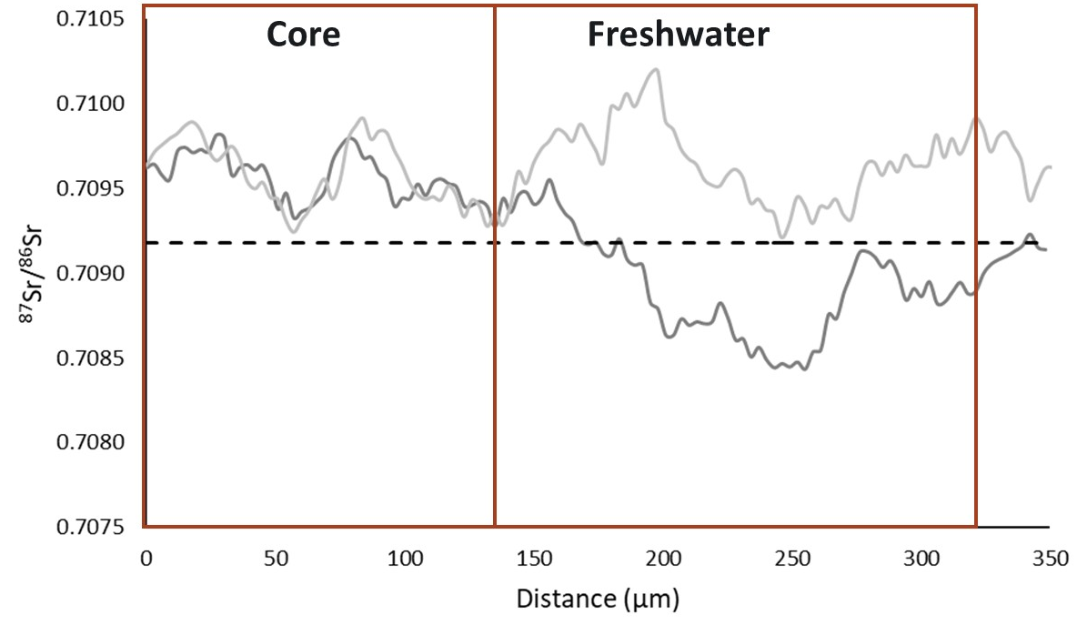
Figure 5.3. The ⁸⁷Sr/⁸⁶Sr otolith transect of two different fish from the reference pink salmon population in Hartney Bay, Prince William Sound (PWS). The ⁸⁷Sr/⁸⁶Sr of seawater (0.70918) is indicated by the black dashed line. The location of the core and freshwater portion of the otolith are indicated in the figure. These individuals are representative of the two different life history trends observed in PWS fish otoliths. The ⁸⁷Sr/⁸⁶Sr of the light grey fish never falls below the global marine strontium isotopic value after the core. The ⁸⁷Sr/⁸⁶Sr of the dark grey fish does fall below the global marine strontium isotopic value after the core, trending in the direction of the freshwater signature of Hartney Bay. Although this second fish indicates a clear departure from the core for the freshwater portion of the otolith in the downward direction, the otolith value does not reach equilibrium with water from Hartney Bay (⁸⁷Sr/⁸⁶Sr = 0.707002).

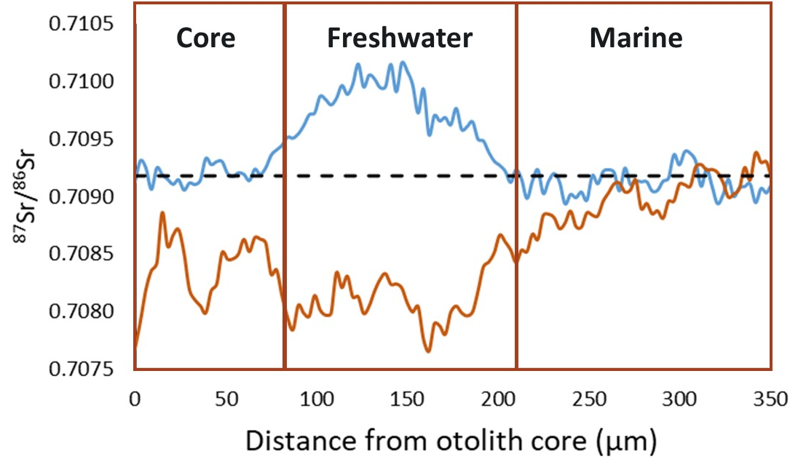
Figure 5.4: The ⁸⁷Sr/⁸⁶Sr otolith transect of representative fish from Camp-99 (representing a Northern Alaska freshwater captured fish, blue) and Elson Lagoon (representing a Northern Alaska marine captured fish, orange). The ⁸⁷Sr/⁸⁶Sr of seawater (0.70918) is indicated by the black dashed line. The location of the otolith core, as well as the freshwater and marine portions, are indicated in the figure. Towards the end of both transects, the ⁸⁷Sr/⁸⁶Sr value approaches the global marine value, likely reflecting the migration of this fish to the ocean after emergence from the gravel. The average ⁸⁷Sr/⁸⁶Sr for Northern Alaska water samples from this study was 0.711256 +1.51E-3. Therefore, the Elson Lagoon fish is likely not of Arctic origin because the otolith ⁸⁷Sr/⁸⁶Sr signature decreases after the core. However, the otolith ⁸⁷Sr/⁸⁶Sr of the Camp-99 fish increases after the core, meaning that Arctic origin cannot be ruled out for this individual.

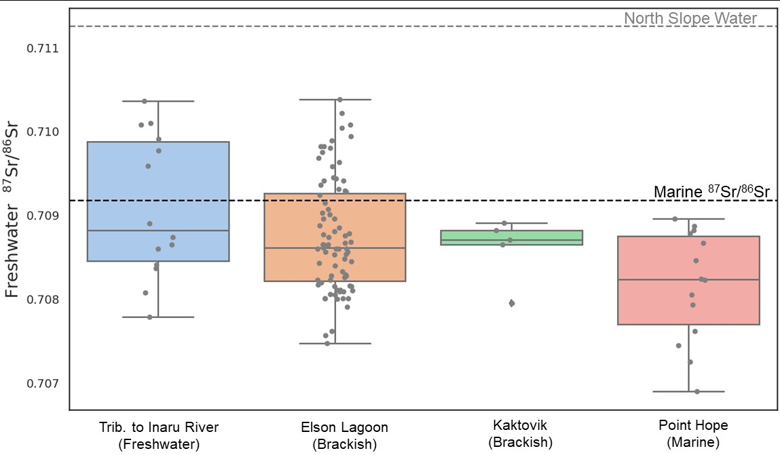
Figure 5.5. Otolith ⁸⁷Sr/⁸⁶Sr in the freshwater portion for fish collected on the North Slope of Alaska. For reference, the ⁸⁷Sr/⁸⁶Sr of seawater (0.70918) is indicated by the black dashed line. The average ⁸⁷Sr/⁸⁶Sr for Northern Alaska water samples from this study (0.711256 +1.51E-3) is indicated by the grey dashed line. The majority of fish examined in this study had a freshwater ⁸⁷Sr/⁸⁶Sr otolith value lower than the global marine value, indicating that these fish are likely not originating from Northern Alaskan rivers.

Sr/Ca and Ba/Ca
There were significant differences between all groups of NAK fish based on the Sr/Ca in both the freshwater and core portions of the otolith (Table 5.3). However, there were no significant differences between groups of NAK fish for Ba/Ca in either the freshwater or core portions of the otolith. Sr/Ca and Ba/Ca are often used together in fisheries geochemistry studies to investigate origins of fish, as they co-vary (Peek and Celementz, 2012). The relationship between Sr/Ca and Ba/Ca for NAK fish in this study is shown in Figure 5.6.

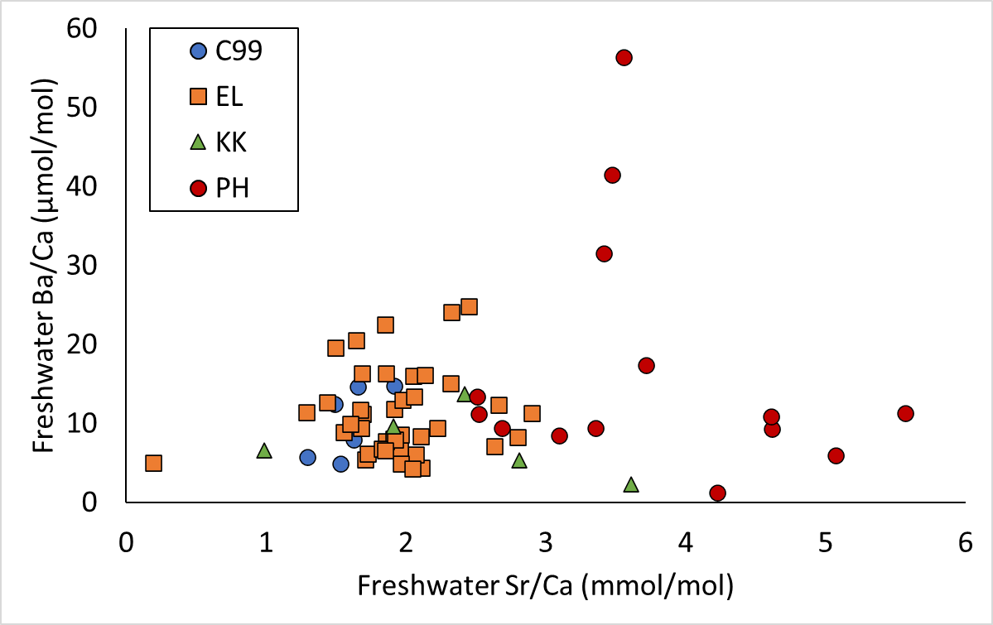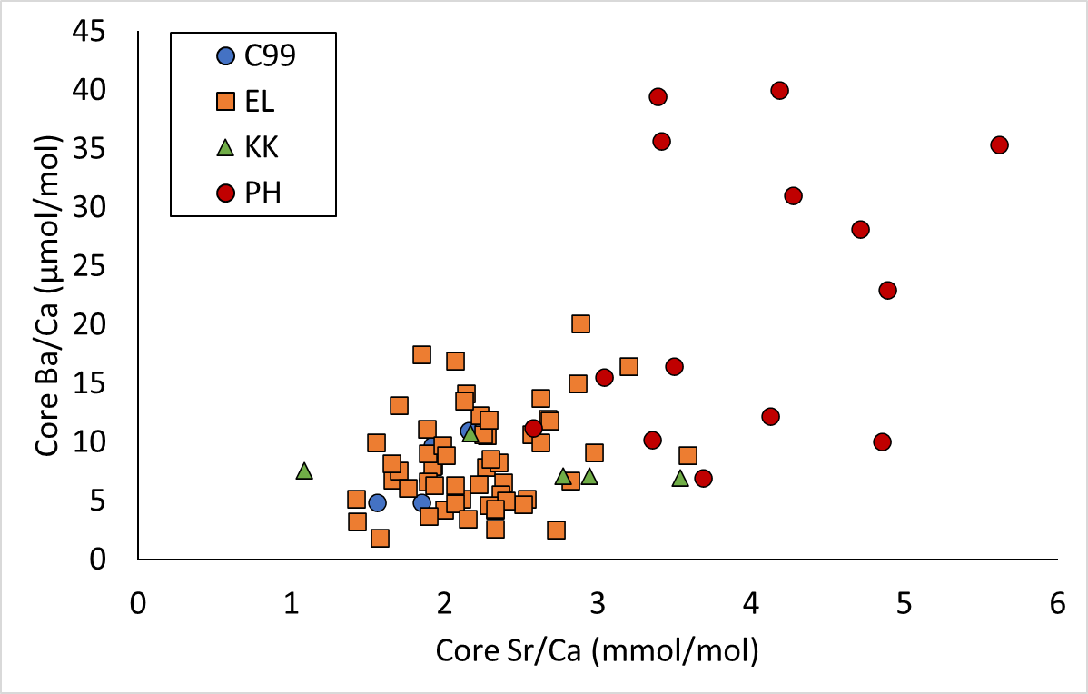
Figure 5.6: Relationship between Sr/Ca and Ba/Ca for the freshwater (left) and core (right) portions of the otolith.

Some individual otoliths did have anomalously high Ba/Ca values (>20 µmol/mol) in both the core and freshwater portions of the otolith. This indicates that there is potential for Ba/Ca to be used as a marker to determine the origins of pink salmon. However, as water Ba/Ca can vary widely on a seasonal basis due to differences in input and flow (see discussion on elemental ratios in Chapter 2), water sampling on a finer temporal scale to capture seasonal variability in Ba/Ca in NAK rivers would be necessary to use Ba/Ca as a discriminative marker of origin.

4. Discussion
The shift of sub-Arctic populations of pink salmon northward has the potential to drastically impact the Arctic ecosystem. Using otolith geochemical markers, this study concluded that the majority (65%) of adult pink salmon caught in the Arctic were likely not of local origin. However, for a small but notable minority of fish (35%) origin in the Arctic could not be conclusively ruled out. If pink salmon are in fact reproducing in the Arctic this could have profound consequences for native subsistence fisheries in the Arctic and for the ecosystem as a whole (Carothers et al., 2018; Dunmall et al., 2013).
Recent reports indicate that pink salmon are increasing in abundance in the Arctic (Carothers et al., 2019; Chila et al., 2022; Dunmall et al., 2018, 2013; Eisner et al., 2013). It is not surprising that pink salmon may be attempting to colonize newly accessible habitat, given that they have the highest stray rate among Pacific salmon (Hendry et al., 2004; Keefer and Caudill, 2014; Pess et al., 2012; Quinn, 2004). The stray rate of pink salmon has been estimated to be between 2.5 to >10%, depending on the population (Keefer and Caudill, 2014; Pess et al., 2012). This high stray rate provides the potential for pink salmon to colonize newly available habitat in the Arctic. Pink salmon have previously been shown to rapidly colonize areas when new habitat becomes available. For example, after a passage barrier at Hell’s Gate was removed in the Frasier River, pink salmon established spawning populations quickly and became abundant within decades (Pess et al., 2012). The Arctic’s dynamic conditions may pose a challenge in finding suitable habitats for egg rearing and juvenile survival, despite the potential opportunities for colonization by pink salmon strays (Dunmall et al., 2016). For example, life cycle models examining the response of pink salmon to warming conditions in the northern Bering Sea suggest that the majority of variability in survival observed for juvenile pink salmon in the Bering Sea occurs during early life history stages (Farley et al., 2020).
Pink salmon have been observed spawning in several streams in Northern AK and the Canadian Arctic (Carothers et al., 2019; Stephenson, 2006), although the production of viable offspring from these individuals has not been confirmed. However, the successful spawning and early marine survival of chum salmon has been established via the presence of a juvenile chum salmon in Arctic waters (Dunmall et al., 2022), indicating that the North Slope of AK does have viable salmon spawning habitat. Notably, the juvenile chum salmon reported by Dunmall et al. (2022) was captured near Kaktovik, one of the locations where adult pink salmon were captured in fresh water in the present study. Previous research has indicated that physical conditions could provide the opportunity for pink salmon to successfully reproduce in the Arctic (Dunmall et al., 2016; Farley et al., 2020; Irvine et al., 2009).
For example, considering the thermal tolerance limits of pink salmon and the locations of perennial Arctic groundwater streams, indicates that there are several tributaries vulnerable to pink salmon establishment in AK and the Yukon Territory (Canada) (Dunmall et al., 2016). Although none of the streams examined by Dunmall et al. (2016) overlap with the sites examined in the present study, this indicates that groundwater streams can provide sufficient thermal refugia for incubation of pink salmon. Additionally, the subarctic Bering Sea offers the opportunity for juvenile salmon to overwinter in an area with higher temperatures that could allow for marine survival (Irvine et al., 2009). Overall, pink salmon possess a tremendous capacity for the straying and colonization of newly available habitat in the Arctic due to their high stray rate, limited rearing time in freshwater, overall population abundance, short 2-year lifecycle, and high population productivity (Dunmall et al., 2016; Farley et al., 2020; Pess et al., 2012; Quinn, 2004).
Although most fish in this study were not locally produced, there was a small but substantial proportion of fish (35%) for which Arctic origin could not be ruled out. In this study, adult fish were captured in August in freshwater locations in Northern AK, which overlaps with the documented spawning migration timing for pink salmon (Quinn, 2004). Therefore, it is intriguing that some of the fish for which Arctic origin could not be ruled out were captured at Camp-99 during this time. Although this could indicate some fish were returning to their stream of origin as adults, it cannot definitively concluded that these fish are of Arctic origin due to several factors. For example, previous work has shown that adult pink salmon can demonstrate a phenomenon known as “reverse migration,” in which fish make short-term movements, on the order of minutes to hours, between fresh and saltwater during their spawning migration (Maselko et al., 2003; Morita, 2022). As many as 10% of fish entering a stream demonstrated this probing behavior in pink salmon in southeastern AK streams (Maselko et al., 2003). It is unclear why individuals may make several transitions back and forth between freshwater and saltwater during spawning migration but reasons such as probing behavior to locate their natal river or to assess favorable spawning conditions and behavioral thermoregulation, have been proposed (Maselko et al., 2003; Morita, 2022).
Strontium isotopic compositions have been widely used to identify the origin of fish (Bourret and Clancy, 2018; Kennedy et al., 2000; Miller and Kent, 2009). In this study, otolith ⁸⁷Sr/⁸⁶Sr was the most discriminative geochemical marker to determine provenance. Although Sr/Ca and Ba/Ca have been used to identify the origin and migration patterns of fish (Chen et al., 2015; Linley et al., 2016; Miller, 2011), in this study Sr/Ca and Ba/Ca concentrations overlapped between PWS and Northern AK study locations. However, due to the wide range in Ba/Ca water concentrations, there is potential for this marker to be used for future applications to fisheries geochemistry studies in the Arctic. Although there were differences in strontium isotopic composition and elemental ratios between different rivers in Northern AK, small sample sizes in this study prevented statistical analyses to determine discriminative differences. The ⁸⁷Sr/⁸⁶Sr of water in this study was consistent with data previously reported for Northern AK by Brennan et al., 2014. There is a distinct trend in geochemical markers north of the Alaska Range (Fig. 2) which allows for the conclusion that adult salmon captured on the North Slope with otolith ⁸⁷Sr/⁸⁶Sr above the global marine value (0.70918) are likely not originating from southern AK populations.
This study used the reference population of PWS fish to demonstrate that otolith chemistry can successfully identify freshwater residency in pink salmon. However, no individuals from PWS had an otolith ⁸⁷Sr/⁸⁶Sr signature that matched water from the region (0.707224). As otolith and water ⁸⁷Sr/⁸⁶Sr typically exhibit a 1:1 relationship (Kennedy et al., 2000), I hypothesize that this indicates fish did not have time to equilibrate the freshwater signature of their natal habitat before moving to the marine environment. Therefore, although the freshwater portion of the otolith could be identified in this study, this data could not be used to assign a discriminative origin for these fish. Previous research has demonstrated that it takes approximately 3-4 weeks for otolith chemistry to reach equilibrium with the water (Doubleday et al., 2013), although changes can be seen in as little as 2-3 days (Chen et al., 2015). In Pacific salmon, the equilibration time for ⁸⁷Sr/⁸⁶Sr during the transition from yolk to exogenous feeding can be over 30 days, with several factors such as population and the magnitude of difference of isotopic sources to the otolith, influencing the equilibration time (Janak et al., 2021). Although Sr isotopic ratios were the most discriminative marker in this study, the combination of geochemical markers could be especially useful in future studies because changes in otolith ⁸⁷Sr/⁸⁶Sr and elemental ratios have been shown to equilibrate on slightly different timescales. For example, Hegg et al., (2019) found that ⁸⁷Sr/⁸⁶Sr equilibrated more gradually, while elemental ratios of manganese, barium, and strontium had more rapid equilibrations. While markers such as ⁸⁷Sr/⁸⁶Sr and elemental ratios have a prolonged equilibration time, posing challenges in identifying the origin of pink salmon based on geochemical analysis, δ¹⁸O could prove valuable due to its relatively faster equilibration time, provided sufficient geochemical variation exists in the Arctic.
Another factor that can confound interpretation is the influence of maternal signatures in the otolith. Pacific salmon otoliths have been shown to have a significant influence from the signature of the mother in the core (Hegg et al., 2019; Janak et al., 2021; Miller and Kent, 2009). Maternal influence on offspring otoliths occurs because the geochemical signature of the egg yolk will often be reflective of the maturation environment, which can be significantly different from the spawning environment in the case of Pacific salmon (Hegg et al., 2019; Quinn, 2005; Volk et al., 2000, Miller and Kent 2008). Given that otoliths begin to develop prior to hatch and exogenous feeding, the isotopic signature of the otolith will reflect a heavy influence of the maternal contribution to the yolk, with maternal contributions of greater than 90% in some salmonids (Hegg et al., 2019; Janak et al., 2021). Although the marine maternal signature in the otolith core is useful in definitively identifying the freshwater portion of the otolith, it can confound interpretation of the freshwater location where fish reared.
Despite the fact that pink salmon have been reported in increasing abundance in recent years (Carothers et al., 2019; Chila et al., 2022; Dunmall et al., 2018, 2013; Eisner et al., 2013), the distribution and abundance of pink salmon in the Arctic is still not well understood. Although this study indicates that most of the pink salmon observed are likely not produced in Arctic watersheds, it also suggests that there may be potential established populations reproducing successfully in the Arctic. This provides further support to the growing body of evidence indicating that pink salmon have a high potential to invade the Arctic and take advantage of previously inaccessible habitat. Decreases in sea ice, coupled with increase temperatures have already led to an observed increase in primary productivity in the Arctic (Ardyna and Arrigo, 2020; Rawlins, 2021). These changes in habitat can potentially result in higher survival of juvenile salmonids, leading to the establishment of self-sustaining Arctic populations of pink salmon (Dunmall et al., 2022; Lewis et al., 2020; Moss et al., 2009).
Developing tools to better understand the use of Arctic habitat by pink salmon is critical for developing mitigation and management measures for a dynamic region. With continued climate warming, there will be increased opportunities for pink salmon in the Arctic (Dunmall et al., 2016, 2013; Farley et al., 2020; Rawlins, 2021). Pink salmon are known for their high population productivity (Quinn, 2004), meaning that if they were to establish successful spawning populations in the Arctic, it could have significant impacts on native subsistence fish species (Carothers et al., 2018; Pecuchet et al., 2020). Well-documented impacts of invasive species on native ecosystems in aquatic environments include predation, disease, as well as pressure from resource competition (as reviewed by Gallardo et al., 2016). Additionally, as global climate change continues to drive increased physical changes in the Arctic, the region may become further exploited for resources such as oil and natural gas (Romasheva and Dmitrieva, 2021; Southcott et al., 2018). If pink salmon do establish populations in the area, it will be important to balance the conservation of these populations with the need to develop resources in the Arctic. Therefore, it is important to continue to improve our understanding of how these fish are making use of newly accessible habitat and how this will impact native fish species and the ecosystem as a whole.

5. Conclusions
In this study, presents the first application of otolith chemistry to investigate the origins of pink salmon. In a dynamic and remote region, further developing tools like otolith microchemistry that reveal information about fish life history and can be analyzed retrospectively are important to improving our understanding of ecosystem dynamics in the region. The results presented here indicate that most adult pink salmon collected in the Arctic were not of local origin, however, Arctic origin cannot be ruled out for some of the fish examined in this study. This finding, along with the favorable conditions for pink salmon in the region, warrants future study on the establishment of pink salmon populations in the Arctic.

Acknowledgements
Funding for this project was provided by the U.S. Department of the Interior, Bureau of Ocean Energy Management through a grant to the University of Alaska-Fairbanks Coastal and Marine Institute. I would like to acknowledge the research team for this project: Kristen Gorman (PI, University of Alaska-Fairbanks), Peter Rand (Co-PI, Prince William Sound Science Center), Todd Sformo (Co-PI, North Slope Borough), Kimberly Pikok (North Slope Borough), Ana Stringer (North Slope Borough), Timothy Linley (Co-PI, Pacific Northwest National Lab/Mainstem Fish Research), Jill Janak (Pacific Northwest National Lab), and Lisa Kant (Pacific Northwest National Lab). Adult pink salmon from Northern Alaska were collected by native, subsistence fishers. Strontium isotopic samples were analyzed in the Environmental Signatures Lab at PNNL (Chief Scientist: Eirik Krogstad, Analyst: Steve Shen).
References
Abdul-Aziz, O.I., Mantua, N.J., Myers, K.W., 2011. Potential climate change impacts on thermal habitats of Pacific salmon ( Oncorhynchus spp.) in the North Pacific Ocean and adjacent seas . Can. J. Fish. Aquat. Sci. 68, 1660–1680. https://doi.org/10.1139/f2011-079
Ardyna, M., Arrigo, K.R., 2020. Phytoplankton dynamics in a changing Arctic Ocean. Nat. Clim. Chang. 10, 892–903. https://doi.org/10.1038/s41558-020-0905-y
Barnett-Johnson, R., Grimes, C.B., Royer, C.F., Donohoe, C.J., 2008. Identifying the contribution of wild and hatchery Chinook salmon (Oncorhynchus tshawytscha) to the ocean fishery using otolith microstructure as natural tags. Can. J. Fish. Aquat. Sci. 29, 1683–1692. https://doi.org/10.1139/F07-129
Bermingham, E., Forbes, S.H., Friedland, K., Pla, C., 1991. Discrimination between Atlantic Salmon (Salmo salar) of North American and European Origin using Restriction Analyses of Mitochondrial DNA. Can. J. Fish. Aquat. Sci. 48, 884–893.
Bourret, S.L., Clancy, N.G., 2018. Using forensic geochemistry via fish otoliths to investigate an illegal fish introduction. Can. J. Fish. Aquat. Sci. 75, 1778–1783. https://doi.org/10.1139/cjfas-2018-0082
Brennan, S.R., Fernandez, D.P., Mackey, G., Cerling, T.E., Bataille, C.P., Bowen, G.J., Wooller, M.J., 2014. Strontium isotope variation and carbonate versus silicate weathering in rivers from across Alaska: Implications for provenance studies. Chem. Geol. 389, 167–181. https://doi.org/10.1016/j.chemgeo.2014.08.018
Brennan, S.R., Fernandez, D.P., Zimmerman, C.E., Cerling, T.E., Brown, R.J., Wooller, M.J., 2015. Strontium isotopes in otoliths of a non-migratory fish (slimy sculpin): Implications for provenance studies. Geochim. Cosmochim. Acta 149, 32–45. https://doi.org/10.1016/j.gca.2014.10.032
CAFF, 2019. State of the Arctic Freshwater Biodiversity Report.
Campana, S.E., 1999. Chemistry and composition of fish otoliths: Pathways, mechanisms and applications. Mar. Ecol. Prog. Ser. 188, 263–297. https://doi.org/10.3354/meps188263
Campana, S.E., Stefánsdóttir, R.B., Jakobsdóttir, K., Sólmundsson, J., 2020. Shifting fish distributions in warming sub-Arctic oceans. Sci. Rep. 10, 1–14. https://doi.org/10.1038/s41598-020-73444-y
Carothers, C., Seitz, A., Sutton, T., 2018. How is climate change affecting subsistence (or traditional) fisheries in the high Arctic? Arct. Answers AA-015.
Carothers, C., Sformo, T.L., Cotton, S., George, J.C., Westley, P.A.H., 2019. Pacific salmon in the rapidly changing arctic: Exploring local knowledge and emerging fisheries in Utqiaġvik and Nuiqsut, Alaska. Arctic 72, 273–288. https://doi.org/10.14430/arctic68876
Chen, K.-Y., Ludsin, S.A., Corey, M., Collingsworth, P.D., Nims, M.K., Olesik, J.W., van Tassell, J.J., Marschall, E., 2015. Experimental and field evaluation of otolith strontium as a marker to discriminate between river-spawning populations of walleye in Lake Erie. Can. J. Fish. Aquat. Sci. 74, 693–701.
Cheung, W.W.L., Jones, M.C., Reygondeau, G., Stock, C.A., Lam, V.W.Y., Frölicher, T.L., 2016. Structural uncertainty in projecting global fisheries catches under climate change. Ecol. Modell. 325, 57–66. https://doi.org/10.1016/j.ecolmodel.2015.12.018
Chila, Z., Dunmall, K.M., Proverbs, T.A., Lantz, T.C., Hunters, A., Hunters, I., Hunters, S.H., Hunters, O., Hunters, P., 2022. Inuvialuit knowledge of Pacific salmon range expansion in the western Canadian Arctic. Can. J. Fish. Aquat. Sci. 79, 1042–1055. https://doi.org/10.1139/cjfas-2021-0172
Crozier, L.G., Burke, B.J., Chasco, B.E., Widener, D.L., Zabel, R.W., 2021. Climate change threatens Chinook salmon throughout their life cycle. Commun. Biol. 4, 222. https://doi.org/10.1038/s42003-021-01734-w
Crozier, L.G., Hendry, A.P., Lawson, P.W., Quinn, T.P., Mantua, N.J., Battin, J., Shaw, R.G., Huey, R.B., 2008. PERSPECTIVE: Potential responses to climate change in organisms with complex life histories: evolution and plasticity in Pacific salmon. Evol. Appl. 1, 252–270. https://doi.org/10.1111/j.1752-4571.2008.00033.x
Crozier, L.G., Hutchings, J.A., 2014. Plastic and evolutionary responses to climate change in fish. Evol. Appl. 7, 68–87. https://doi.org/10.1111/eva.12135
Crozier, L.G., Scheuerell, M.D., Zabel, R.W., 2011. Using time series analysis to characterize evolutionary and plastic responses to environmental change: A case study of a shift toward earlier migration date in sockeye salmon. Am. Nat. 178, 755–773. https://doi.org/10.1086/662669
Dommasnes, A., 2010. Changing distribution of marine fish. Arct. Biodivers. Trends 2010 78–80.
Doubleday, Z.A., Izzo, C., Woodcock, S.H., Gillanders, B.M., 2013. Relative contribution of water and diet to otolith chemistry in freshwater fish. Aquat. Biol. 18, 271–280. https://doi.org/10.3354/ab00511
Dunmall, K.M., Mcnicholl, D.G., Reist, J.D., 2018. Community-based Monitoring Demonstrates Increasing Occurrences and Abundances of Pacific Salmon in the Canadian Arctic from 2000 to 2017. Tech. Rep. 8–12. https://doi.org/10.23849/npafctr11/87.90
Dunmall, K.M., McNicholl, D.G., Zimmerman, C.E., Gilk-Baumer, S.E., Burril, S., von Biela, V.R., 2022. First juvenile chum salmon confirms successful reproduction for Pacific salmon in the North American Arctic. Can. J. Fish. Aquat. Sci. 79, 703–707. https://doi.org/10.1139/cjfas-2022-0006
Dunmall, K.M., Mochnacz, N.J., Zimmerman, C.E., Lean, C., Reist, J.D., 2016. Using thermal limits to assess establishment of fish dispersing to high-latitude and high-elevation watersheds. Can. J. Fish. Aquat. Sci. 73, 1750–1758. https://doi.org/10.1139/cjfas-2016-0051
Dunmall, K.M., Reist, J.D., Carmack, E.C., Babaluk, J.A., Heide-Jorgensen, M.P., Docker, M.F., 2013. Pacific Salmon in the Arctic: Harbingers of Change. Responses Arct. Mar. Ecosyst. to Clim. Chang. https://doi.org/10.4027/ramecc.2013.07
Dunnigan, J.L., Linley, T.J., Janak, J.M., Nims, M.K., Garavelli, L., Mcmichael, G.A., 2023. Otolith 87 Sr / 86 Sr identifies natal origin , movement and life history of Burbot Lota lota in the Kootenai River following 45 years of impoundment. Ecol. Freshw. Fish 1–15. https://doi.org/10.1111/eff.12712
Eisner, L., Hillgruber, N., Martinson, E., Maselko, J., 2013. Pelagic fish and zooplankton species assemblages in relation to water mass characteristics in the northern Bering and southeast Chukchi seas. Polar Biol. 36, 87–113. https://doi.org/10.1007/s00300-012-1241-0
Elderfield, H., 1986. Strontium isotope stratigraphy. Palaeogeogr. Palaeoclimatol. Palaeoecol. 57, 71–90.
Farley, E. V., Murphy, J.M., Cieciel, K., Yasumiishi, E.M., Dunmall, K., Sformo, T., Rand, P., 2020. Response of Pink salmon to climate warming in the northern Bering Sea. Deep. Res. Part II Top. Stud. Oceanogr. 177, 104830. https://doi.org/10.1016/j.dsr2.2020.104830
Fossheim, M., Primicerio, R., Johannesen, E., Ingvaldsen, R.B., Aschan, M.M., Dolgov, A. V., 2015. Recent warming leads to a rapid borealization of fish communities in the Arctic. Nat. Clim. Chang. 5, 673–677. https://doi.org/10.1038/nclimate2647
Gallardo, B., Clavero, M., Sánchez, M.I., Vilà, M., 2016. Global ecological impacts of invasive species in aquatic ecosystems. Glob. Chang. Biol. 22, 151–163. https://doi.org/10.1111/gcb.13004
GeoRem, 2022. GeoReM: Geological and Environmental Reference Materials [WWW Document]. Max Planck Inst. URL http://georem.mpch-mainz.gwdg.de/
Gibson-Reinemer, D.K., Johnson, B.M., Martinez, P.J., Winkelman, D.L., Koenig, A.E., Woodhead, J.D., 2009. Elemental signatures in otoliths of hatchery rainbow trout (Oncorhynchus mykiss): Distinctiveness and utility fo detecting origins and movement. Can. J. Fish. Aquat. Sci. 66, 513–524. https://doi.org/10.1139/F09-015
Gover, T.R., Nims, M.K., Van Tassell, J.J., Collingsworth, P.D., Olesik, J.W., Ludsin, S.A., Marschall, E.A., 2014. How Much Cleaning is Needed When Processing Otoliths from Fish Larvae for Microchemical Analysis? Trans. Am. Fish. Soc. 143, 779–783. https://doi.org/10.1080/00028487.2014.889749
Hegg, J.C., Kennedy, B.P., Chittaro, P., 2019. What did you say about my mother? The complexities of maternally derived chemical signatures in otoliths. Can. J. Fish. Aquat. Sci. 76, 81–94. https://doi.org/10.1139/cjfas-2017-0341
Hegg, J.C., Kennedy, B.P., Chittaro, P.M., Zabel, R.W., 2013. Spatial structuring of an evolving life-history strategy under altered environmental conditions. Oecologia 172, 1017–1029. https://doi.org/10.1007/s00442-012-2564-9
Hendry, A.P., Castric, H. V., Kinnison, M.T., Quinn, T.P., 2004. The evolution of philopatry and dispersal: homing versus straying in salmonids, in: Hendry, A.P., Stearns, S.C. (Eds.), Evolution Illuminated: Salmon and Their Relatives. Oxford University Press, New York, pp. 52–91.
Huntington, H.P., Danielson, S.L., Wiese, F.K., Baker, M., Boveng, P., Citta, J.J., De Robertis, A., Dickson, D.M.S., Farley, E., George, J.C., Iken, K., Kimmel, D.G., Kuletz, K., Ladd, C., Levine, R., Quakenbush, L., Stabeno, P., Stafford, K.M., Stockwell, D., Wilson, C., 2020. Evidence suggests potential transformation of the Pacific Arctic ecosystem is underway. Nat. Clim. Chang. 10, 342–348. https://doi.org/10.1038/s41558-020-0695-2
Hutchins, D.A., Jansson, J.K., Remais, J. V., Rich, V.I., Singh, B.K., Trivedi, P., 2019. Climate change microbiology — problems and perspectives. Nat. Rev. Microbiol. 17, 391–396. https://doi.org/10.1038/s41579-019-0178-5
IPCC, 2022. Climate Change 2022: Impacts, Adaptation and Vulnerability.
Irvine, J.R., Macdonald, R.W., Brown, R.J., Godbout, L., Reist, J.D., Carmack, E.C., 2009. Salmon in the Arctic and How They Avoid Lethal Low Temperatures. North Pacific Anadromous Fish Comm. Bull. 5, 39–50.
Janak, J.M., Linley, T.J., Harnish, R., Shen, S., 2021. Partitioning maternal and exogenous diet contributions to otolith 87Sr/86Sr in Kokanee Salmon (Oncorhynchus nerka). Can. J. Fish. Aquat. Sci.
Jepsen, N., Aarestrup, K., Økland, F., Rasmussen, G., 1998. Survival of radio-tagged Atlantic salmon (Salmo salar (L.)) and trout (Salmo trutta L.) smolts passing a reservoir during seaward migration. Hydrobiologia 371–372, 347–353. https://doi.org/10.1007/978-94-011-5090-3_39
Keefer, M.L., Caudill, C.C., 2014. Homing and straying by anadromous salmonids: A review of mechanisms and rates. Rev. Fish Biol. Fish. 24, 333–368. https://doi.org/10.1007/s11160-013-9334-6
Kennedy, B.P., Blum, J.D., Folt, C.L., Nislow, K.H., 2000. Using natural strontium isotopic signatures as fish markers: Methodology and application. Can. J. Fish. Aquat. Sci. 57, 2280–2293. https://doi.org/doi:10.1139/cjfas-57-11-2280
Lewis, K.M., Van Dijken, G.L., Arrigo, K.R., 2020. Changes in phytoplankton concentration now drive increased Arctic Ocean primary production. Science (80-. ). 369, 198–202. https://doi.org/10.1126/science.aay8380
Linley, T.J., Krogstad, E.J., Nims, M.K., Langshaw, R.B., 2016. Geochemical signatures in fin rays provide a nonlethal method to distinguish the natal rearing streams of endangered juvenile Chinook Salmon Oncorhynchus tshawytscha in the Wenatchee River, Washington. Fish. Res. 181, 234–246. https://doi.org/10.1016/j.fishres.2016.04.004
Maselko, J.M., Wertheimer, A.C., Thedinga, J.F., 2003. Selection and Application of a Mark-and-Recapture Technique for Estimating Pink Salmon Escapements. NOAA Tech. Memo. NMFS-AFSC-137 54.
McMichael, G.A., Eppard, M.B., Carlson, T.J., Carter, J.A., Ebberts, B.D., Brown, R.S., Weiland, M., Ploskey, G.R., Harnish, R.A., Deng, Z.D., 2010. The Juvenile Salmon Acoustic Telemetry System: A New Tool. Fisheries 35, 9–22. https://doi.org/10.1577/1548-8446-35.1.9
Miller, J.A., 2011. Effects of water temperature and barium concentration on otolith composition along a salinity gradient: Implications for migratory reconstructions. J. Exp. Mar. Bio. Ecol. 405, 42–52. https://doi.org/10.1016/j.jembe.2011.05.017
Miller, J.A., Kent, A.J.R., 2009. The determination of maternal run time in juvenile Chinook salmon (Oncorhynchus tshawytscha) based on Sr/Ca and 87Sr/86Sr within otolith cores. Fish. Res. 95, 373–378. https://doi.org/10.1016/j.fishres.2008.09.030
Morita, K., 2022. Reverse migration of adult pink salmon (Oncorhynchus gorbuscha) to the sea after their return to fresh water. Environ. Biol. Fishes 105, 1825–1832. https://doi.org/10.1007/s10641-021-01139-y
Moss, J.H., Murphy, J.M., Farley Jr., E. V, Eisner, L.B., Andrews, A.G., 2009. Juvenile Pink and Chum Salmon Distribution, Diet, and Growth in the Northern Bering and Chukchi Seas. North Pacific Anadromous Fish Comm. Bull. 5, 191–196.
Mueter, F.J., Weems, J., Farley, E. V., Sigler, M.F., 2017. Arctic Ecosystem Integrated Survey (Arctic Eis): Marine ecosystem dynamics in the rapidly changing Pacific Arctic Gateway. Deep. Res. Part II Top. Stud. Oceanogr. 135, 1–6. https://doi.org/10.1016/j.dsr2.2016.11.005
Nims, M.K., Walther, B.D., 2014. Contingents of Southern Flounder from Subtropical Estuaries Revealed by Otolith Chemistry. Trans. Am. Fish. Soc. 143, 721–731. https://doi.org/10.1080/00028487.2014.892535
Pearce, N.J.G., Perkins, W.T., Westgate, J.A., Gorton, M.P., Jackson, S.E., Neal, C.R., Chenery, S.P., 1997. A compilation of new and published major and trace element data for NIST SRM 610 and NIST SRM 612 glass reference materials. Geostand. Newsl. 21, 115–144. https://doi.org/10.1111/j.1751-908X.1997.tb00538.x
Pecuchet, L., Blanchet, M.A., Frainer, A., Husson, B., Jørgensen, L.L., Kortsch, S., Primicerio, R., 2020. Novel feeding interactions amplify the impact of species redistribution on an Arctic food web. Glob. Chang. Biol. 26, 4894–4906. https://doi.org/10.1111/gcb.15196
Pess, G.R., Hilborn, R., Kloehn, K., Quinn, T.P., 2012. The influence of population dynamics and environmental conditions on pink salmon (Oncorhynchus gorbuscha) recolonization after barrier removal in the Fraser river, British Columbia, Canada. Can. J. Fish. Aquat. Sci. 69, 970–982. https://doi.org/10.1139/F2012-030
Quinn, T.P., 2004. The behavior and ecology of Pacific Salmon and Trout. Universtity of Washington Press, Seattle.
Rawlins, M.A., 2021. Increasing freshwater and dissolved organic carbon flows to Northwest Alaska’s Elson lagoon. Environ. Res. Lett. 16. https://doi.org/10.1088/1748-9326/ac2288
Reis-Santos, P., Gillanders, B.M., Sturrock, A.M., Izzo, C., Oxman, D.S., Lueders-Dumont, J.A., Hüssy, K., Tanner, S.E., Rogers, T., Doubleday, Z.A., Andrews, A.H., Trueman, C., Brophy, D., Thiem, J.D., Baumgartner, L.J., Willmes, M., Chung, M.T., Johnson, R.C., Heimbrand, Y., Limburg, K.E., Walther, B.D., 2022. Reading the biomineralized book of life: expanding otolith biogeochemical research and applications for fisheries and ecosystem-based management, Reviews in Fish Biology and Fisheries. Springer International Publishing. https://doi.org/10.1007/s11160-022-09720-z
Romasheva, N., Dmitrieva, D., 2021. Energy resources exploitation in the russian arctic: Challenges and prospects for the sustainable development of the ecosystem. Energies 14. https://doi.org/10.3390/en14248300
Rooker, J.R., Secor, D.H., De Metrio, G., Schloesser, R., Block, B.A., Neilson, J.D., 2008. Natal homoing and connectivity in Atlantic Bluefin Tuna populations. Science (80-. ). 322, 742–744. https://doi.org/10.1126/science.1161473
Southcott, C., Abele, F., Natcher, D., Parlee, B., 2018. Resources and Sustainable Development in the Arctic, 1st Editio. ed. Routledge, London.
Sparks, M.M., Westley, P.A.H., Falke, J.A., Quinn, T.P., 2017. Thermal adaptation and phenotypic plasticity in a warming world: Insights from common garden experiments on Alaskan sockeye salmon. Glob. Chang. Biol. 23, 5203–5217. https://doi.org/10.1111/gcb.13782
Steiner, N.S., Cheung, W.W.L., Cisneros-Montemayor, A.M., Drost, H., Hayashida, H., Hoover, C., Lam, J., Sou, T., Sumaila, U.R., Suprenand, P., Tai, T.C., VanderZwaag, D.L., 2019. Impacts of the changing ocean-sea ice system on the key forage fish arctic cod (Boreogadus saida) and subsistence fisheries in the Western Canadian arctic-evaluating linked climate, ecosystem and economic (CEE) models. Front. Mar. Sci. 6. https://doi.org/10.3389/fmars.2019.00179
Stephenson, S.A., 2006. A review of the occurence of Pacific salmon (Oncorhynchus spp.) in the Canadian Western Arctic. Arctic 59, 37–46.
Thorrold, S.R., Jones, C.M., Campana, S.E., McLaren, J.W., Lam, J.W.H., 1998. Trace element signatures in otoliths record natal river of juvenile American shad (Alosa sapidissima). Limnol. Oceanogr. 43, 1826–1835. https://doi.org/10.4319/lo.1998.43.8.1826
Walther, B.D., 2019. The art of otolith chemistry: Interpreting patterns by integrating perspectives. Mar. Freshw. Res. 1643–1658. https://doi.org/10.1071/MF18270
Wiig, Ø., Aars, J., Born, E.W., 2008. Effects of climate change on polar bears. Sci. Prog. 91, 151–173. https://doi.org/10.3184/003685008X324506
Wrona, F.J., Johansson, M., Culp, J.M., Jenkins, A., Johanna, M., Myers-smith, I.H., Prowse, T.D., Vincent, W.F., Wookey, P.A., 2016. of a Changing Hydrological Regime. J. Geophys. Res. Biogeosciences 650–674. https://doi.org/10.1002/2015JG003133.Received
Zimmerman, C.E., Swanson, H.K., Volk, E.C., Kent, A.J.R., 2013. Species and life history affect the utility of otolith chemical composition for determining natal stream of origin for pacific salmon. Trans. Am. Fish. Soc. 142, 1370–1380. https://doi.org/10.1080/00028487.2013.811102

